Cleanroom Design Specifications (GB50073-2013)
Author:Jason Peng
Cleanroom Engineering Technology Manager of Deiiang Company,
Product R&D Manager of GDC Inc. Cleanroom Equipment Manufacturing Company,
Executive Director of Guangdong Cleanroom Industry Association of China,
Engaged in R&D of related products for 15 years, with rich relevant technical experience

1.Location Selection and General Plan Layout of Cleanrooms
1.1 The location selection of modular cleanrooms shall comply with the following provisions and be determined after comparison of technical and economic plans:
1) It shall be located in areas with low concentrations of dust and harmful gases in the atmosphere and good natural environment.
2) It shall be far away from railways, docks, airports, major traffic arteries, and factories, storage silos, yards, etc. that emit a large amount of dust and harmful gases and have serious air pollution, vibration or noise interference. When it is not possible to be far away from serious air pollution sources, it shall be located on the upwind side of the maximum frequency wind, or on the downwind side of the minimum frequency wind throughout the year.
3) It shall be arranged in areas within the factory area where the environment is clean and people and logistics do not pass through or rarely pass through.
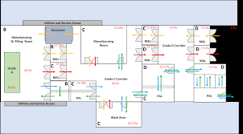
1.2 For the location selection of cleanrooms with micro-vibration control requirements, the vibration impact of the existing vibration sources in the surrounding area shall be actually measured, and it shall be determined after analysis and comparison with the allowable vibration values of precision cleanroom Equipment and precision instruments.
1.3 The shortest distance between the fresh air outlet of the clean workshop and the edge of the traffic main road should be greater than 50m.
1.4 A circular fire truck lane should be set up around the clean workshop, and a fire truck lane can also be set up along the two long sides of the workshop.
1.5 The road surface around the clean workshop should be made of materials with good overall performance and less dust.
1.6 Greening should be carried out around the clean workshop. Lawns can be planted, but plants that are harmful to production should not be planted, and firefighting operations should not be hindered.

2. Process plane layout and design comprehensive coordination
2.1 The process plane layout should comply with the following provisions:
1) The process plane layout should be reasonable and compact. Only necessary process equipment, as well as processes and studios with air cleanliness level requirements should be arranged in the clean room or clean area.
2) On the premise of meeting the production process and noise requirements, the clean room or clean area with strict air cleanliness requirements should be close to the air conditioning room, and the processes and studios with the same air cleanliness level should be arranged in a centralized manner.
3) The processes in the clean room that have strict requirements on air cleanliness should be arranged on the upwind side, and the process equipment that is prone to pollution should be arranged near the return air outlet.
4) The transportation routes for the installation and maintenance of large equipment should be considered, and equipment installation ports and inspection ports should be reserved.
5) When there is frequent contact between rooms with different air cleanliness levels, measures to prevent pollution should be set up, such as airlocks, transfer windows, etc.
6) A separate material entrance should be set up, the material transfer route should be the shortest, and the material should be cleaned before entering the clean room (area).
2.2 The plane and space design of the clean workshop should meet the requirements of the production process and air cleanliness level. Clean areas, personnel purification, material purification and other auxiliary rooms should be arranged in zones, and should be comprehensively coordinated with various technical facilities such as production operations, process equipment installation and maintenance, pipeline layout, air flow pattern, and purification Air conditioning system.
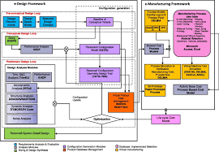
2.3 There should be fewer compartments in the clean room, but they should be separated in the following cases:
1) According to the fire hazard classification of production, between Class A and Class B and non-Class A and Class B adjacent production sections, or when there are fire separation requirements.
2) When there are separation requirements according to the product production process.
3) Between two production sections with few production connections and often not used at the same time.
2.4 Under the condition of meeting the production process and air cleanliness level requirements, the layout of various fixed technical facilities in the clean room should give priority to the requirements of the purification air conditioning system. Fixed technical facilities include air supply vents, lighting, return air vents, various pipelines, etc.

3. Personnel purification and material purification
3. 1 Personnel purification and material purification rooms and facilities should be set up in the clean room, and living rooms and other rooms should be set up as needed.
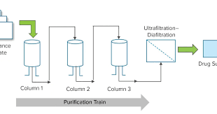
3.2 The setting of personnel purification rooms and living rooms shall comply with the following provisions:
1) Personnel purification rooms such as rain gear storage, shoe changing, outer clothes storage, and clean work clothes change should be set up.
2) Living rooms such as toilets, washing rooms, shower rooms, lounges, and air shower , airlock rooms, work clothes washing rooms and drying rooms can be set up as needed.
3.3 The design of personnel purification rooms and living rooms shall comply with the following provisions:
1) Shoe cleaning measures should be set up at the entrance of personnel purification rooms.
2) Rooms for outer clothes storage and clean work clothes change should be set up separately.
3) Outer clothes storage wardrobes should be set up one cabinet per person according to the designed number of people, and clean work clothes should be hung in clean cabinets with air showers.
4) Washing rooms should be equipped with hand washing and drying facilities.
5) air shower should be set up at the entrance of clean area personnel and adjacent to the clean work clothes changing room. Single-person air shower rooms are set up for every 30 people in the maximum shift. When there are more than 5 staff members in the clean area, a bypass door should be installed on one side of the air shower room.
6) Vertical unidirectional clean rooms stricter than level 5 should be equipped with airlocks.
7) Toilets shall not be installed in clean areas. Toilets in personnel purification rooms should be equipped with an anteroom.
3.4 The flow of people should comply with the following regulations:
1) The flow of people should avoid reciprocating intersections.
2) The layout of personnel purification rooms and living rooms should be based on the personnel purification procedures
3.5 According to different air cleanliness levels and the number of staff, the building area of personnel purification rooms and living rooms in the clean workshop should be reasonably determined, and should be calculated based on the average number of people in the clean area design, 2m2, 4m2 per person.
3.6 The air purification requirements of clean work clothes changing rooms and washing rooms should be determined according to the product process requirements and the air cleanliness level of the adjacent clean room (area).
3.7 The equipment and material entrances and exits in the clean room should be set up with material purification rooms and facilities according to the properties, shapes and other characteristics of the equipment and materials. The layout of the material purification room should prevent the purified materials from being contaminated during the transfer process.
Design Specifications for Cleanrooms in Pharmaceutical industry (GB50457-2008)

4. Site Selection and General Plan Layout

4.1 Site Selection
1.1 The selection of the site location should be determined after comparison of technical and economic plans, and should comply with the following provisions:
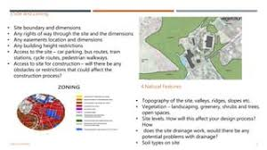
1) It should be located in an area with low atmospheric dust concentration, bacteria concentration and harmful gas concentration, and a good natural environment.
2) It should be away from railways, docks, airports, traffic arteries, factories, warehouses, and yards that emit a lot of dust and harmful gases, and away from areas with serious air pollution, water pollution, vibration or noise interference; if it is not possible to stay away from the above areas, it should be located on the windward side of the maximum frequency wind direction.
1.2 The distance between the fresh air outlet of the pharmaceutical industry clean workshop and the road red line on the side of the municipal traffic trunk road near the base should be greater than 50m.
4.2 General layout
2.1 The general layout of the factory area should comply with the national overall design requirements for industrial enterprises, and should meet the requirements of environmental protection, and at the same time prevent cross contamination.
2.2 The factory area should be laid out according to production, administration, life and auxiliary functions.
2.3 The pharmaceutical industry clean workshop should be arranged in a clean environment in the factory area, and the flow of people and goods does not pass through or rarely passes through the area, and should be laid out according to the characteristics of drug production. For pharmaceutical factories that produce both raw materials and preparations, the raw material production area should be located on the leeward side of the maximum frequency wind direction of the preparation production area throughout the year. Areas with serious pollution such as waste treatment and boiler rooms should be located on the leeward side of the maximum frequency wind direction of the factory area throughout the year.
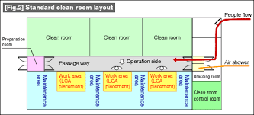
2.4 The production plant of highly allergenic drugs such as penicillins should be located on the leeward side of the maximum frequency wind direction of other production plants throughout the year.
2.5 The setting of animal rooms shall comply with the relevant provisions of the current national standard "Experimental Animal Environment and Facilities" GB/T14925.
2.6 A circular fire truck lane should be set up around the clean workshop of the pharmaceutical industry. If there are difficulties, a fire truck lane can be set up along the two long sides of the workshop.
2.7 The setting of the main roads in the factory area shall meet the requirements of the separation of people and goods flow. The surface layer of the road around the clean workshop of the pharmaceutical industry should be made of materials with good integrity and less dust.
4,2,8 The area around the clean workshop of the pharmaceutical industry should be greened. The exposed soil area in the factory area should be reduced, and plants that are easy to emit pollen or have adverse effects on drug production should not be planted.

5. Process design

5.1 Process layout
5.1.1 The process layout shall comply with the requirements of the production process and air cleanliness level, and shall be comprehensively determined according to the requirements of various technical measures such as process equipment installation and maintenance, pipeline layout, air flow pattern and purification air conditioning system.
5.1.2 The process layout should prevent cross contamination between human and material flows and should meet the following basic requirements:
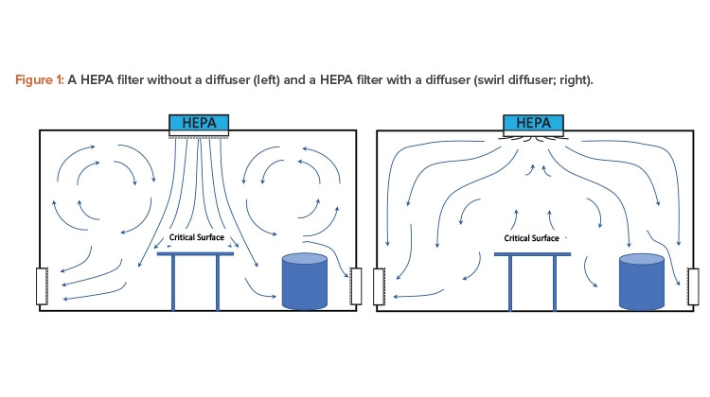
1) Separate entrances and exits should be set for personnel and materials to enter and exit the production area. Special entrances and exits should be set for materials that are easily contaminated during the production process.
2) Separate purification rooms and facilities should be set for personnel and materials before entering the pharmaceutical clean room (area).
3) The setting of process equipment and facilities in the pharmaceutical clean room (area) should meet the production process requirements. The production and storage areas shall not be used as passages for staff outside the area.
4) Elevators for transporting personnel and materials should be set separately. Elevators should not be set in pharmaceutical clean rooms. Elevators that need to be set in pharmaceutical clean areas should take measures to ensure the air cleanliness level requirements of pharmaceutical clean areas.
5) The material transfer route in the pharmaceutical industrial clean room should be short.
5.1.3 Under the premise of meeting the process conditions, the layout of various fixed technical facilities in the pharmaceutical industrial clean room should be comprehensively coordinated according to the requirements of the purification air conditioning system.
5.1.4 The layout of pharmaceutical clean rooms (areas) shall meet the following requirements:
1) Under the premise of meeting the production process and noise level requirements, the French pharmaceutical clean rooms (areas) with high air cleanliness levels should be arranged close to the air conditioning room, and the layout of processes and pharmaceutical clean rooms (areas) with the same air cleanliness levels should be relatively concentrated.
2) Personnel and material transfer between pharmaceutical clean rooms (areas) with different air cleanliness levels should have pollution prevention measures. 5.1.5 In the pharmaceutical industry clean workshop, it is advisable to set up storage areas for raw and auxiliary materials, semi-finished products and finished products that are suitable for the production scale near the production area. It is advisable to set up areas for inspection and qualified products in the storage area, and measures can also be taken to control the inspection and qualified status of materials. Special areas should be set up for unqualified products.
5.1.6 The production plant of highly allergenic drugs such as penicillins should be set up independently. The production plant of contraceptive drugs, BCG, and tuberculin must be set up separately from the production plant of other drugs.
5.1.7 The following drug production areas must be arranged separately:
1) β-lactam structure drug production area and other production areas.
2) Chinese herbal medicine pre-treatment, extraction and concentration production areas and their preparation production areas.
3) Animal organs, tissue washing or processing production areas and their preparation production areas.
4) Production areas of radioactive drugs containing different nuclides.
5.1.8 The raw materials and finished products of the following biological products shall not be processed and filled in the same production area at the same time:
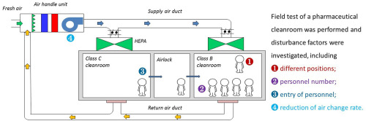
1) Production bacteria and virus strains and non-production bacteria and virus strains.
2) Production cells and non-production cells.
3) Highly toxic products and non-highly toxic products.
4) Dead virus products and live virus products.
5) Products before detoxification and products after detoxification.
6) Live vaccines and inactivated vaccines.
7) Different types of human blood products.
8) Different types of preventive products.
5.1.9 The layout and air cleanliness level of production auxiliary rooms shall meet the following requirements:
1) The sampling room should be set up in the storage area, and the air cleanliness level of the sampling environment should be the same as that of the pharmaceutical clean room (area) where the sampled materials are used. The sampling room for sterile materials should be a sterile clean room, and the air cleanliness level of the sampling environment should be the same as that of the sterile operation environment where the sampled materials are used, and corresponding material and personnel purification rooms should be set up.
2) The Weighing Room should be set up in the production area, and the air cleanliness level of the weighing room should be the same as that of the pharmaceutical clean room (area) where the weighed materials are used.
4) The material preparation room should be arranged close to the weighing room. The air cleanliness level of the material preparation room should be the same as that of the weighing room.
● Equipment, containers and tools in the pharmaceutical clean room (area) with air cleanliness level of 100 and 10000 should be cleaned outside the area, and the air cleanliness level of the cleaning room should not be lower than 100000.
●If equipment, containers and tools need to be cleaned in the pharmaceutical clean area, the air cleanliness level of the cleaning room should be the same as that of the pharmaceutical clean area.
●Equipment, containers and tools should be dried after washing and should be stored at the same air cleanliness level as the pharmaceutical clean room (area) where the equipment, containers and tools are used. Equipment, containers and tools in sterile clean rooms (areas) should be sterilized in time after washing, and should be stored under measures to maintain their sterility after sterilization.
5.1.10 The cleaning tool washing and storage room of the pharmaceutical clean room (area) should not be set up in the clean area. If it is necessary to set it up in the clean area, the air cleanliness level of the pharmaceutical clean room (area) should be the same as that of the clean room (area) where the cleaning tools are used. Cleaning tool washing and storage rooms should not be set up in sterile clean areas.
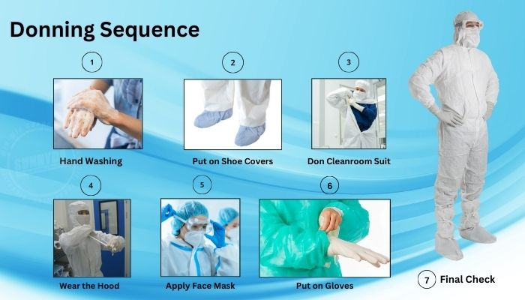
5.1.11 The washing, drying and finishing of clean work clothes shall meet the following requirements:
1) The air cleanliness level of the clean work clothes washing, drying and finishing room in the pharmaceutical clean room (area) with air cleanliness level of 100000 and above shall not be lower than 300000.
2) Clean work clothes in the pharmaceutical clean room (area) with air cleanliness level of 300000 can be washed and dried in a clean environment.
3) Work clothes used in pharmaceutical clean rooms (areas) with different air cleanliness levels shall be washed and finished separately.
4) Washing and drying equipment for sterile work clothes should be dedicated. Sterile work clothes after washing and drying should be finished under unidirectional air cleanliness level 100 and should be sterilized in time.
5.1.12 The setting of sterile clean room shall be determined according to Articles 5.1.9, 5.1.13 and Appendix A of this specification.
5.1.13 The layout and air cleanliness level of the quality control laboratory shall comply with the following provisions:
1) Inspection, Chinese medicine specimen, sample observation and other laboratories shall be set up separately from the drug production area.
2) The setting of various laboratories shall comply with the following requirements:
Laboratories such as positive control, sterility inspection, microbial limit inspection and antibiotic microbial inspection, as well as radioactive isotope inspection rooms, shall be set up separately.
The sterility inspection room and microbial limit inspection laboratory shall be sterile clean rooms, and their air cleanliness level shall not be lower than Class 10,000, and shall be equipped with.

Reference to relevant international standards:
ISO 14644: Cleanrooms and Controlled Environments
URL: https://www.iso.org/iso-14644-cleanrooms-and-controlled-environments.html

ISO 13485: Medical Devices - Quality Management Systems
URL: https://www.iso.org/iso-13485-medical-devices.html

Good Manufacturing Practice (GMP)
URL: https://www.fda.gov/drugs/development-resources/good-manufacturing-practice-gmp-resources

Federal Standard 209E (Superseded by ISO 14644)
URL: https://www.dtic.mil/dtic/tr/fulltext/u2/a484358.pdf

ANSI/ISO/ASQ Q9001: Quality Management Systems
URL: https://www.iso.org/iso-9001-quality-management.html

ISO 14698: Biocontamination Control
URL: https://www.iso.org/iso-14698-biocontamination-control.html

IEC 60601: Medical Electrical Equipment
URL: https://www.iec.ch/standards/iec-60601

ISO 50001: Energy Management Systems
URL: https://www.iso.org/iso-50001-energy-management.html

ASTM E2871: Standard Guide for the Design and Testing of Cleanrooms
URL: https://www.astm.org/Standards/E2871.htm

ISO 14001: Environmental Management Systems
URL: https://www.iso.org/iso-14001-environmental-management.html

